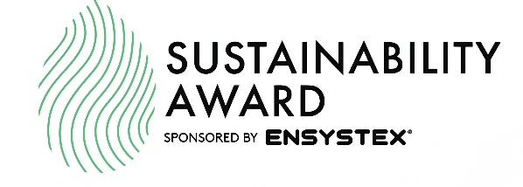

Sustainability Award 2026 – Sponsored by Ensystex
Business Name:
Number of Employees:
Nominee’s Name:
Business Address:
Contact Phone:

1. At its core, how does your organisation define sustainability within the New Zealand context?
Consider environmental stewardship, long-term business resilience, and responsibility to people, whenua, and community.

2. In practice, how is sustainability embedded in your day-to-day operations?
Outline specific initiatives or systems in place, such as waste reduction, chemical management, energy use, transport, procurement, or innovation in service delivery.

3. In terms of transparency, how do you communicate your sustainability commitments and actions to clients and stakeholders?
Include examples such as reporting, client education, marketing material, or on-site practices.

4. From an internal perspective, how are staff informed, trained, and engaged in your sustainability policies and procedures?
Explain how expectations are communicated and how staff participation is encouraged or measured.

5. Looking at outcomes, how do your sustainability initiatives deliver benefits across the environment, workplace safety, and the wider community?
Where possible, describe measurable or observable impacts.

6. From a compliance standpoint, does your business meet all relevant New Zealand environmental, social, and employment legislation?
Include reference to any enforcement actions, prosecutions, or formal investigations within the past five years, if applicable.

7. In relation to marketing and public statements, how do you ensure claims about environmental performance comply with New Zealand fair-trading and consumer-protection laws?
Describe internal checks or approval processes used to avoid greenwashing.

8. With respect to worker wellbeing, does your organisation operate a documented health and safety management system aligned with New Zealand requirements?
Please attach supporting documentation.

9. In governance terms, does your business comply with New Zealand laws relating to human rights, anti-discrimination, environmental protection, health and safety, and corporate conduct?
Provide a brief overview of how compliance is monitored.

10. In line with international and New Zealand expectations, how does your organisation ensure it does not engage in or support child labour or modern slavery?
Confirm whether any workers under 16 are employed outside formal training programmes, and whether supplier checks or policies are in place.
Please attach relevant policies if available.

11. At a broader level, has your organisation adopted a Corporate Social Responsibility (CSR) or sustainability policy that considers impacts on customers, employees, the environment, and the community?
Include examples of community engagement, iwi partnerships, charitable support, or industry leadership.

Submission of Nominations
Please email the completed nomination form and any supporting documentation to:
info@pmanz.nz
Nominations close: 30 April 2026

All information provided will be treated as confidential and used solely for the purpose of assessing entries for the PMANZ Sustainability Award. Feedback will be provided to entrants following the judging process.

